Test Cases

With Euro Currency

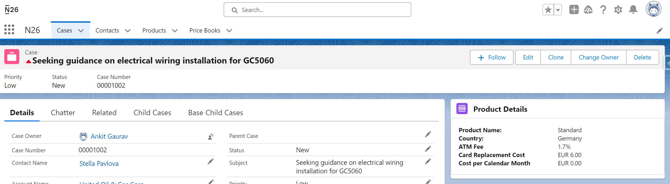

With UK Currency

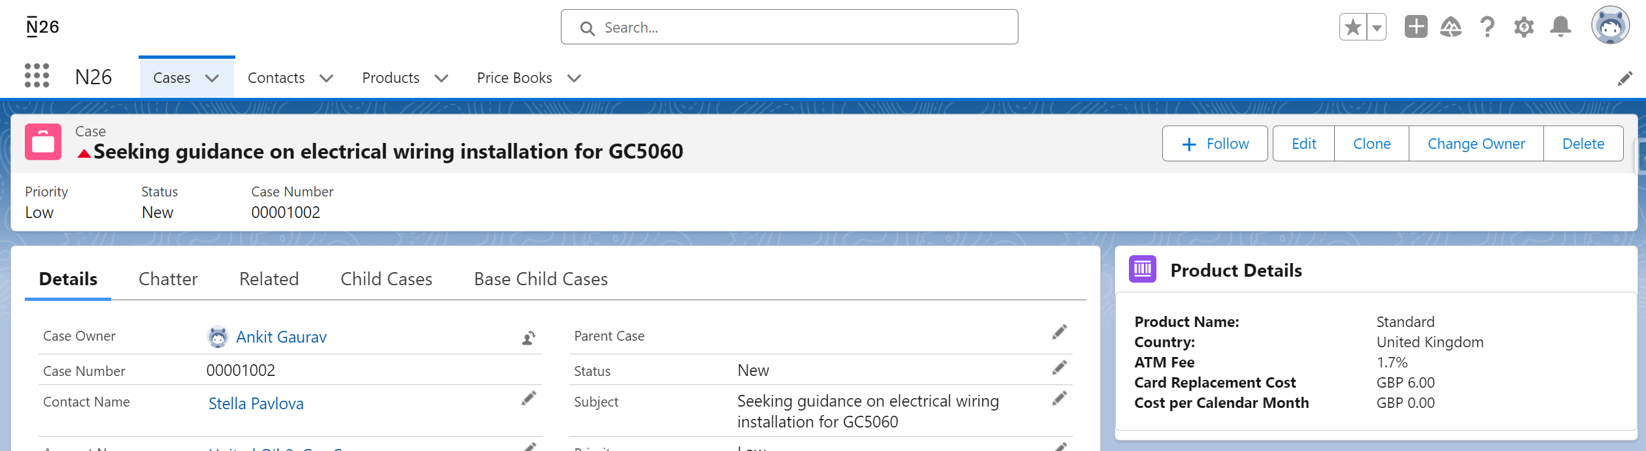

With No PriceBook Entry

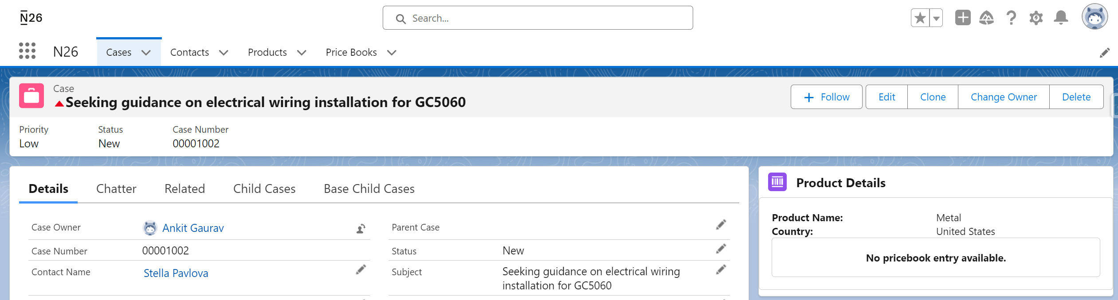

Without Contact Case Record

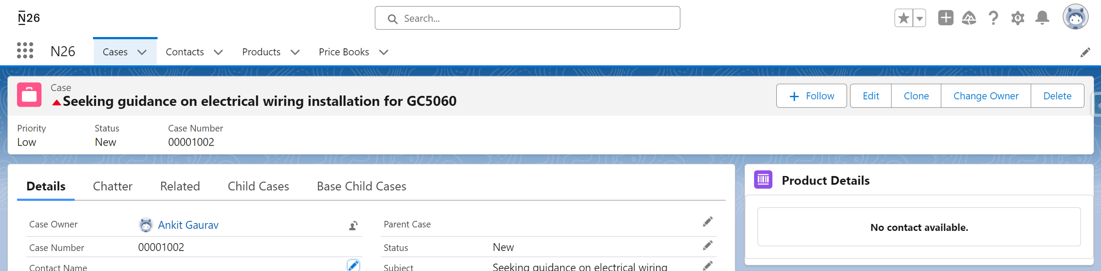

Contact Without Product and Country

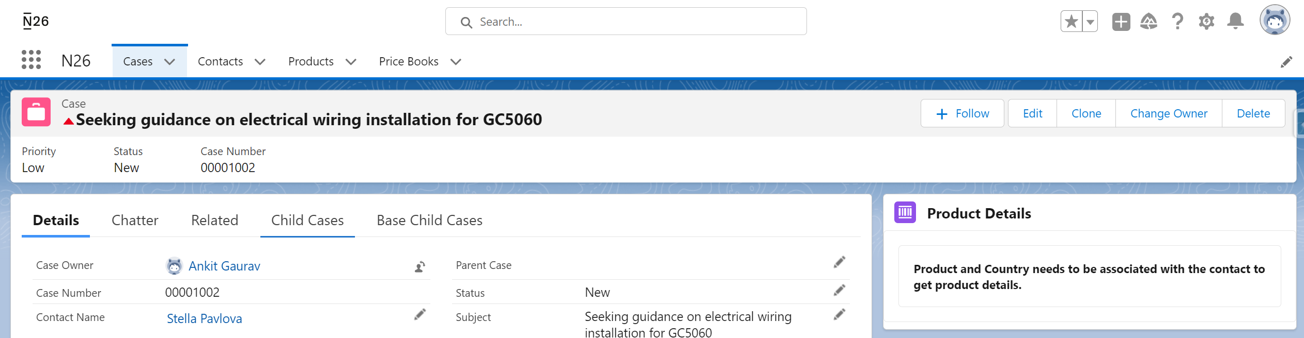

Contact with only Product without Country

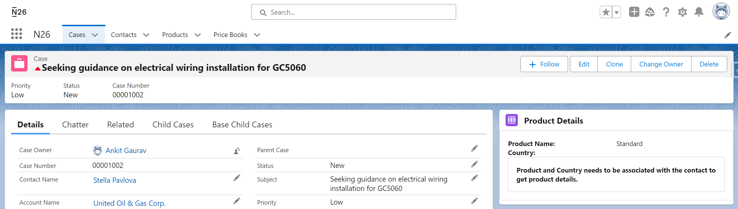

Contact with only Country without Product

